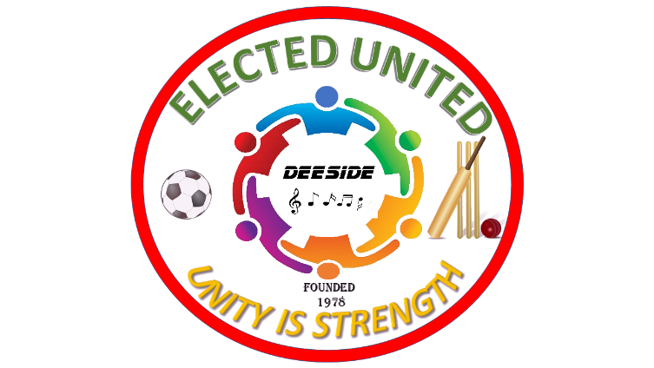

Elected United Table of Contents

- Cover Sheet
- Introduction
- Description of the Logo
- History of the club
- Vision
- Mission statement
- Purpose
- Overview of the club
- Organizational Chart
- Governing body
- Bylaws
- Membership Rules
- Dissolving (Dissolution) of the Organization
- Appendix

- Cover Sheet

- Club Name: Elected United (LLC)
- Principal members: Everyone regardless of age, race religion, gender, origin, sexual orientation
- Address: 247 Huntington Rd, Bridgeport, CT 06604
- Phone: (907)987-0452
- Email: Electedunited@gmail.com
- Website: electedunited.com or electedunited.org
- Social media: Twitter, Facebook, Instagram

- Introduction

  - Elected United is a non-profit organization that was founded in 1978 in Deeside, Trelawny by Rowan Brown, Norice Brown, Vincent Brown, Neville Drummond, Victor Hamilton, Kiston Martin et Al.
  - Membership is not limited to age, gender, ethnicity, sexual orientation, and / or religion.
  - Members work diligently together to promote charity, sports, and community development.

- Description of the Logo

The outer circle represents the continues effort to develop communities from one generation to the other. The circle is “red” because of an historic moment when the founding fathers made tie dye shirts for a soccer match. The colors eventually turned pink when they encountered rain. The colorful people in the center hugging each other depict unity and diversity among members. The word “Deeside” in the middle is the small district in Trelawny, Jamaica where the founding fathers developed the club concept in 1978. Musical notes, cricket bat & ball, and a soccer ball were the instruments of culture and unity. Elected United is the original name and still is today. “Unity is strength” means that when people come together and work together, they can conquer any challenges.

- History of Club (Pending)…

- Vision
To build and strengthen communities through active engagement, volunteerism, and empowerment from one generation to the other.

- Mission Statement
People working collaboratively to strengthen communities through charity, unity, and engagement.

- Purpose
Elected United was established with the purpose of providing mentorship and assistance to the youth and elderly globally by providing community development through feeding charities, education, arts, cultural awareness, and sports.

- Club Overview
  - Being a member of a successful charitable organization is highly desired.
  - Elected United is a Non-Profit Organization comprising of a governing body working together for one cause, uplifting communities.
  - Members will meet frequently to set agendas and work together to create positive impact for the youths and elderly.

- Organizational Chart
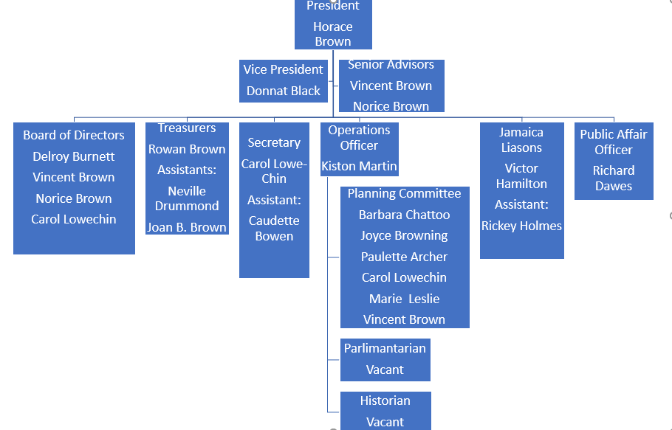

- Governing Body

  - Chief Executive Officer (CEO) – Responsibly for all aspects of the organization and is the final authority in decision making.
  - President – Responsibly for the overall operation of the organization and is the chief advisor to the CEO. He / She will schedule and hold regular meetings to plan and execute the mission of the organization.
  - Vice President – Responsibly for assisting the president in his / her role and is the primary supervisor of committee activities.
  - Operation Office – Responsible for the coordination of events. He / She will collaborate with all members to ensure all events are executed as planned.
  - Chief Financial Officer (Treasurer)– Responsible for all financial and accounting activities with overwatch by the Board of Directors
  - Chief of Administration (Secretary) – Responsible for scheduling meetings, taking minutes, enrollments, and disenrollment of members. Must maintain a database of membership and documentation.
  - Assistant Administrative Officer (Assistant Secretary) – Assist the Secretary and assume full responsibility whenever the Secretary is unavailable.
  - Parliamentarian -Maintains the Constitution and Bylaws, oversees voting, meetings, and procedures.
  - Senior Advisors – Provide leadership and guidance to the president and vice president and other members.
  - Historian – Maintains the chronological log of the organization evens which will include, pictures, videos, and documents.
  - Public Relations Officer – Responsible for promoting the organization through public, private sector, and government contacts and is the primary spokesperson for the organization.
  - Sergeant at Arms – Assist the Parliamentarian by enforcing law and order of the organization. Ensuring that everything is in order prior to meetings and events.
  - Planning Committee Members - Responsible for leading projects, coordinating activities, and ongoing membership activities.
  - Board of Directors (3) –Board of Directors will vote, debate, and decide on matters regarding the organization. There must be a 2/3 majority to approve all matters voted upon. If a decision cannot be reached after two meetings; the vice-president will be the deciding factor.
Name | Position | Email Address | Phone Number | Notes
Horace Brown | CEO
Horace Brown | President
Donnat Black | Vice President
Rowan Brown / Joan B. Brown | Chief Financial Officer (CFO)/ Treasurer
Neville Drummond | Assistant CFO- Treasurer
Kiston Martin | Operations Officer / Sports
Carol Lowechin | Chief of Administration (COA) - Secretary / Board of Director
Claudette Bowen | Assistant COA – Secretary
Vincent Brown | Senior Advisor / Board of Director
Norice Brown | Senior Advisor / Board of Director
 | Parliamentarian
Joyce Browning | Planning Committee
Barbara Chattoo | Planning Committee
Claudette Bowen | Planning Committee
Paulette Archer | Planning Committee
Richard Dawes | Public Relations Officer
 | Sergeant at Arms
Delroy Burnette | Board of Directors |  |  | Accepted on 3/13/21
Barbara Wilby in Jamaica | ??? |  |  | Contacted on 4/24/21. Need to confirm appointment
Hastings Primary Principal | Beneficiary |  |  | Contacted on 4/24/21, but I think she is a beneficiary not a member.
Vacant | Jamaican Liaison
Glenroy (Ricky)Holmes | Assistant Jamaica Liaison

- Bylaws

  - Amendments to the bylaws must be approved by the CEO before implementation into the organization.
  - New bylaws will take effect after ratification by the governing body.
  - Members younger than the age of 17 years old must be sponsored by an adult who assumes full responsible for all decisions regarding such member.
  - Member must be in good moral and civic standings. Known violators of local and federal (national) laws will be disenrolled or denied membership until such time that moral standings are cleared.
  - Members are required to pay monthly dues in one or a combination of the following:
    - $8.33USD/month or $100USD/Year
    - In lieu of money, members who are not able may pay dues by providing volunteered community service of 10 hours per month.
    - Married spouses are automatically enrolled with their spouse on the same membership.
    - A third member of each household will be accepted at 50% of the annual dues.
    - Dues is considered late or delinquent after 30 days of due date.
    - Non-dues paying members will be dropped from roll and official duties until fully reinstated.
    - After missing three consecutive meetings, the Operations Officer will notify the member by email or WhatsApp message that they will be dropped from role if their absence is not due to excusable reasons. Excusable reasons include illness of self or immediate family members, death of family immediate members, catastrophic events such as damages to personal properties due to inclement weather etc.
    - Dues may be paid via the website payment system or established CashApp, Zelle, Paypal or other official medias.
  - If a member is voluntarily or involuntarily terminated from the organization, dues paid will not be refunded.
  - Donations are separate from dues and will be tracked separately.
  - Members may qualify for discounts regarding special events and apparels.
  - There will be only one CEO of the organization, however there may be subsidiary chapters with other governing bodies.
  - The Headquarter for the organization will reside in the United States of America and will oversee all other chapters developed regardless of countries, states, providences, parishes, or districts.
  - Chapters can be formed with their own governing bodies and must be approved and operate under the same, licenses, constitution and bylaws here written.
  - There must be at least a five (5) miles radius between chapters.
  - Each chapter will take on the name of the local community.
For example:
    - Elected United - Bridgeport
    - Elected United – Deeside
  - Elected United – Bounty Hall.
  - Membership perks – See Appendix A
  - Each chapter president will report to the headquarters branch all plans, activities, and seek approval prior to such events. A revenue statement (Balance Sheet) must be reported to the Headquarters of the organization monthly.
  - Nomination for new officers will be held on the first Saturday of November every two (2) years of an even number year. Example: 2022, 2024, 2026 etc.
  - Voting will be done in a combination of ways to include, in person, mailing, social media,
  - With the help of the Parliamentarian, Sergeant at Arms, and Board of Directors, the Vice President will tally the results and announce the results on the fourth (4th) Saturday in December unless it is a holiday, then it will be reported one week before.
  - Newly elected officers will take official responsibility on the first (1st) Saturday of January proceeding announcement. If this day falls on a holiday, then they will take office the week after the holiday.
  - Monthly meetings will be held every second (2nd) Saturday of each month unless it is a holiday, then it will be held the Saturday after the holiday.
  - Each Chapter must host at least two major fund-raising events annually.
  - At least 80 percent (80%) of the proceed must go to a charitable cause. The rest of the proceeds will be used to fund other community projects or operational funds.
  - Members will not be paid for work done for the organization. Work is strictly voluntary.
  - If a member owns a business and provide work for the organization, they must provide a quote and a vote by the executive board will decide if the contract is awarded.
  - The week of August 6th will be the Organization’s awards banquet. This event will be held in various states or countries and will be selected by a vote of executive members during the annual awards presentation. The award banquet will be open to the public and will be hosted by the chapter which was voted to host that year.
  - Political, sexual, vulgar or any apparels deemed offensive will not be tolerated at organization events.
  - Any member wishing to use promote the organization’s name must get approval from the board of directors with final approval from the President.

- Membership Rules
- ​1. I promise to abide by the rules and bylaws set forth by this organization.
- 2. I understand that I must be 18 years old or older unless sponsored by an adult.
- 3. I promise that I will not use Elected United for personal gains or profit.
- 4. I understand that any fraudulent activities will result in suspension or removal without a refund of any financial contributions.
- 5. I agree to the monthly dues of $8.33USD/month or $100USD/Yr. or volunteer service of 10 hours/month.
- 6. I understand that all work done by me is strictly voluntary.
- 7. I understand that if convicted of any crime, that I will be suspended until restored to normal standings.

- Dissolving (Dissolution) of the Organization
- Elected United Corporation is obligated to use the proper procedures recommended by the Secretary of State of Connecticut and the Internal Revenue System (IRS) -501(c)(3) to dissolve the organization should there be any reason for voluntary or involuntary dissolution.
- After a boar decision to dissolve, the corporation will cease transacting business except to the extent necessary to wind up its affairs. All corporate debts and liabilities, to the extent of the corporation’s remaining assets, must be pain or provided for. If any corporate assets are left after paying corporate debts, Elected United Corporation will distribute them to another501(c)(3) group.

- Appendix A (Membership privileges and Perks)
- Discount entry to events
- Picture and nameplate on the Wall of Stars for those making significant contribution (standards will be developed in the future).
- May qualify for emergency assistance from not from organizational fund.
- Can hold official office within the organization.

